8.4 Acids have a low pH. Bases have a high pH

Student worksheet answers (pages 162–163)

Acid and base chemical reactions

1 Summarise the differences between acids and bases in the following table.

|  |  |  |  |  |
| --- | --- | --- | --- | --- |
|  | Acids | | Bases | |
|  | Weak | Strong | Weak | Strong |
| What does it taste like? | sour | | bitter | |
| What does it feel like? | Burning/prickling | | soapy | |
| What does it contain in its chemical structure? | hydrogen (H) | | Carbonates (CO3) | hydroxides (OH) |
| What does it read on the pH scale? | below 7 | | above 7 | |
| Colour in universal indicator? | red | orange | green | blue |
| What colour does litmus paper turn? | turns red in acidic solutions | | turns blue in basic solutions | |
| 3 chemical examples | ethanoic acid (CH3COOH)  carbonic acid (H2CO3)  phosphoric acid (H3PO4) | hydrochloric acid (HCl)  nitric acid (HNO3)  sulfuric acid (H2SO4) | ammonia (NH3)  sodium carbonate (Na2CO3)  clcium carbonate (CaCO3) | sodium hydroxide (NaOH)  potassium hydroxide (KOH)  barium hydroxide (Ba(OH)2) |
| Examples that are found around the home | fruits – citric acid or oxalic acid | car batteries – sulfuric acid | cleaner – ammonia | soap – sodium hydroxide |

2 Label the following diagram of the pH scale.

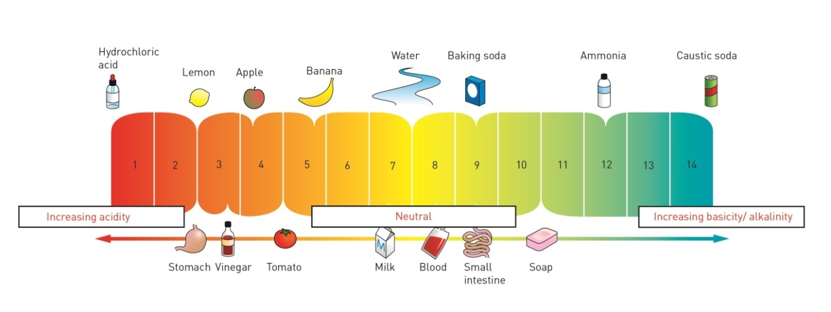

3 What do the colours on the above pH scale represent?

the colour that the pH value would turn with universal indicator

EXTEND YOUR UNDERSTANDING

4 Your teacher puts 3 test tubes on your Science bench and asks you to identify which is the salt solution, the acid solution and the alkali solution. Outline what you would use to determine the answer and what results you would obtain.

Use universal indicator in all 3. Neutral = Yellow, Acid = Red, Base = blue

Use Litmus paper. Acid = red, base = blue, neutral = no change

Other natural indicators may be used

5 The following are results of some substances that have been tested in the science laboratory with a variety of indicators; red litmus, blue litmus and universal indicator. Look at the results and complete the table below.

|  |  |  |  |  |  |
| --- | --- | --- | --- | --- | --- |
| Substance | What colour will red litmus paper turn? | What colour will blue litmus paper turn? | pH read on universal indicator | Acid, base or neutral? | Example of a substance that it could be. |
| A | Stays red | Stays blue | pH 7 | Neutral | Water |
| B | Stays red | Turns red | pH 4 | Weak acid | Lemon juice |
| C | Stays red | Turns red | pH 2 | Acid | Hydrochloric acid |
| D | Turns blue | Stays blue | pH 11 | Base | Sodium hydroxide |
| E | Turns blue | Stays blue | pH 8 | Weak base | Soap |